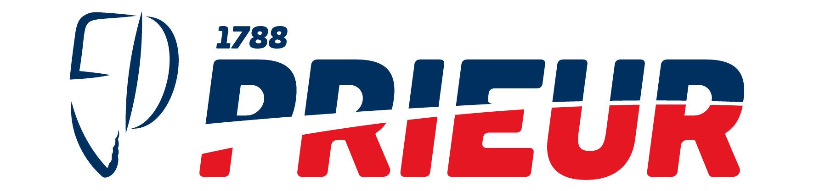

RETURN AND EXCHANGE FORM

FOR RETU RNS AN D EXCHANGES, PLEASE FILL OUT THE INFORMATION BELOW AN D RETURN YOUR U NWANTE D ITEMS TO TH E FOLLOWING ADDRESS

54 Avenue Général de Gaulle, 21110 GENLIS

CUSTOMER INFORMATIONS  FIRST NAM E : | NAME : | ORDER NUMBER :
PHON E : | MAIL :

PRODUCTS TO RETURN
RETU RN FOR SIZE (1) RETU RN FOR REFU ND (2]
SKU REFERENCE | PRODUCT LABEL | QUANTITY | REASON FOR RETURN / EXCHANGE
(I) I F OTH ER, PLEASE SPECI FV
RETURN AND EXCHANGE POLICY
(I) For an exchange
Send the item(s) concerned in the original packaging.
For any exchange, thank you to add to your package a check of 8,40€ to the order of PRIEUR SPORTS related to the forwarding charges of the new article.
As soon as we receive it, we will do as fast as possible to carry out the exchange.

(2) For a refund
Send the item(s) concerned in the original packaging.
Upon receipt of your package, we will refund you on your bank account. Return and refund available within l4 days after receipt of the package.

For any further information, please contact us at the following email address: contact@prieur- sports.com or by phone: 03 80 72 72 24

Any damaged or deteriorated product will not be taken back or exchanged except proven quality defect

Address to which to send your package : Prieur Sports, 54 Avenue Général de Gaulle - 21110 GENLIS

MAKE SURE THAT THE ITEM(S) YOU WISH TO RETURN AND THE RETURN FORM ARE INCLUDED IN THE PACKAGE YOU ARE SENDING BACK TO US

